Link : <http://www.studytonight.com/operating-system/process-scheduling>

Under : Types of Schedulers:

In Medium term scheduler:

Replace the given text by :

**Medium term scheduler**: This scheduler removes the processes from memory (and from active contention for the CPU), and thus reduces the degree of multiprogramming. At some later time, the process can be reintroduced into memory and its execution van be continued where it left off. This scheme is called **swapping.** The process is swapped out, and is later swapped in, by the medium term scheduler.

Swapping may be necessary to improve the process mix, or because a change in memory requirements has overcommitted available memory, requiring memory to be freed up.

This complete process is descripted in the below diagram:

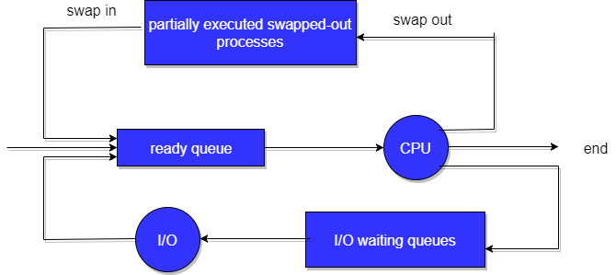

Fig: Addition of medium-term scheduling to the queueing diagram.